***ESDR 2.0 - Tableau Visualization Translation Document***

Please find on the following pages screengrabs of the Tableau Visualizations from the Enhanced School District Reporting (ESDR) 2.0 webpage, followed by tables of the English phrases that are part of the visualizations that we would like translated. If you have any questions/concerns, please contact Roger Hazleden ([roger.hazleden@gov.bc.ca](mailto:roger.hazleden@gov.bc.ca))

1. Community Socio-Economic Information

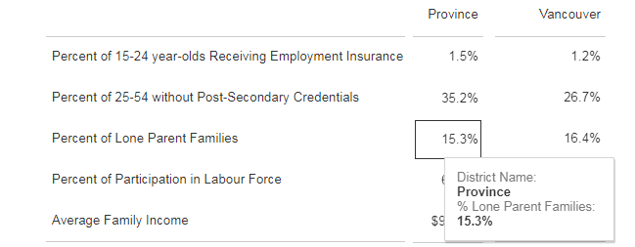

|  |  |
| --- | --- |
| **English** | **French** |
| Percent of 15-24 year-olds receiving Employment Insurance |  |
| Percent of 25-54 year-olds without Post-Secondary Credential |  |
| Percent of Lone-Parent Families |  |
| Percent of Participation in Labour Force |  |
| Average Family Income |  |
| Province |  |
| District Name: |  |

2. Student Enrolment Over Time

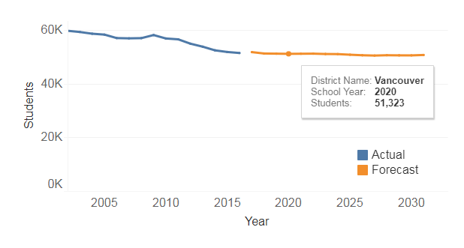

|  |  |
| --- | --- |
| **English** | **French** |
| Students |  |
| Year |  |
| School Year |  |
| Actual |  |
| Forecast |  |

3. Number of Students Across All Grades

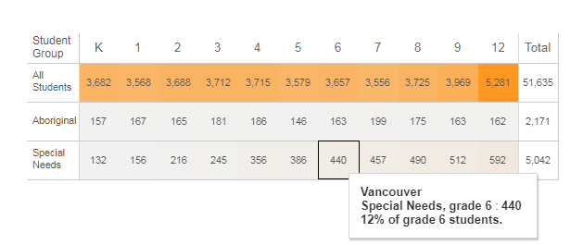

|  |  |
| --- | --- |
| **English** | **French** |
| All Students |  |
| Aboriginal |  |
| Special Needs |  |
| Non-Residents |  |
| Student Group |  |
| Total |  |
| ***X***% of grade ***y*** students |  |

4. Characteristics of Students Entering School

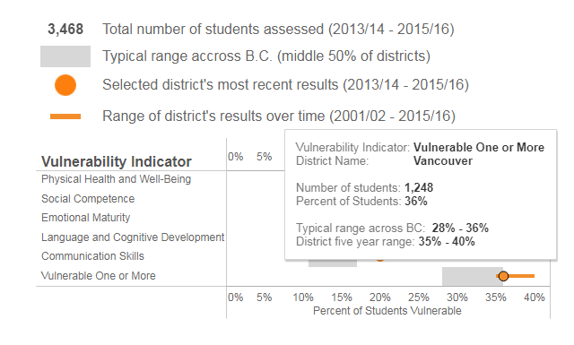

|  |  |
| --- | --- |
| **English** | **French** |
| Total number of students assessed (2013/14 - 2015/16) |  |
| Typical range across B.C. (middle 50% of districts) |  |
| Selected district's most recent results (2013/14 - 2015/16) |  |
| Range of district's results over time (2001/02 - 2015/16) |  |
| Vulnerability Indicator |  |
| Percent of Students Vulnerable |  |
| Physical Health and Well-Being |  |
| Social Competence |  |
| Emotional Maturity |  |
| Language and Cognitive Development |  |
| Communication Skills |  |
| Vulnerable One or More |  |
| Number of Students: |  |
| Percent of Students: |  |
| Typical range across BC: |  |
| District five year range: |  |

5. Completion Rates

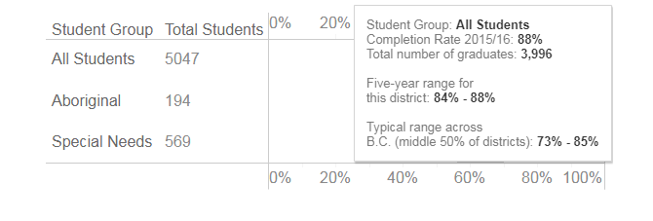

|  |  |
| --- | --- |
| **English** | **French** |
| BC Residents |  |
| Total Students |  |
| Completion Rate 2015/16 |  |
| Total number of graduates |  |
| Five-year range for this district: |  |
| Typical range across B.C. (middle 50% of districts) |  |

6. Foundation Skills Assessment

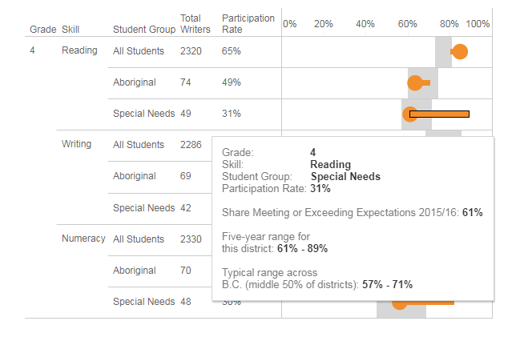

|  |  |
| --- | --- |
| **English** | **French** |
| Grade |  |
| Skill |  |
| Total Writers |  |
| Participation Rate |  |
| Share Meeting or Exceeding Expectations 2015/16: |  |

7. FSA Student Growth Over Time

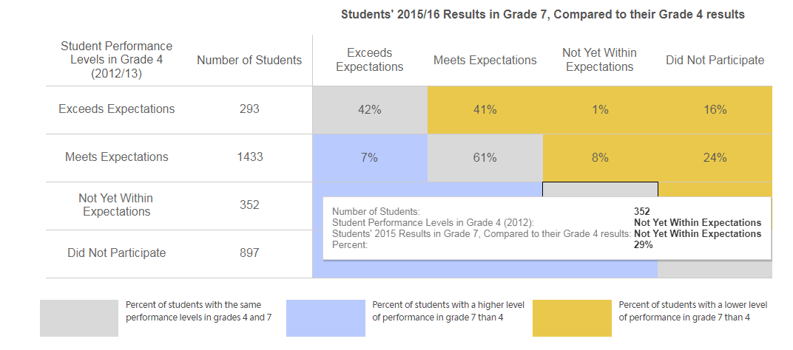

|  |  |
| --- | --- |
| **English** | **French** |
| Student Performance Levels in Grade 4 (2012/13) |  |
| Number of Students |  |
| Exceeds Expectations |  |
| Meets Expectations |  |
| Not Yet Within Expectations |  |
| Did Not Participate |  |
| Students’ 2015/16 Results in Grade 7, Compared to their Grade 4 results |  |

8. Grade-to-Grade Transitions

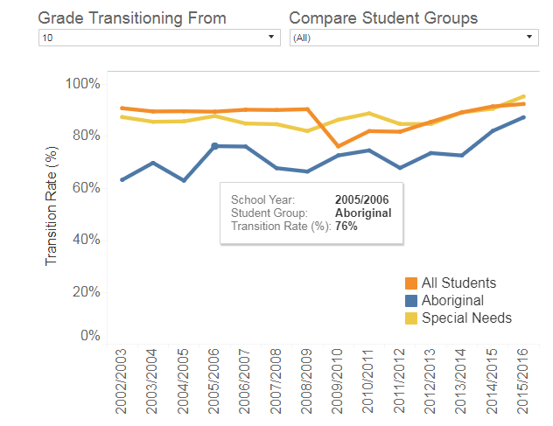

|  |  |
| --- | --- |
| **English** | **French** |
| Grade Transitioning From |  |
| Compare Student Groups |  |
| Transition Rate (%) |  |

9. Student Satisfaction

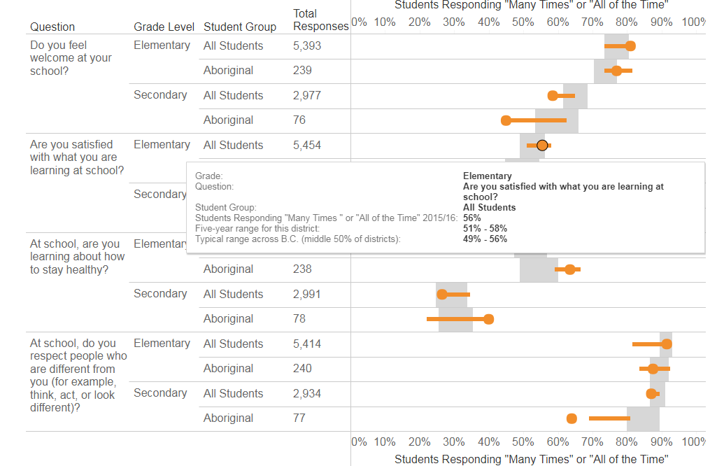

|  |  |
| --- | --- |
| **English** | **French** |
| Do you feel welcome at your school? |  |
| Are you satisfied with what you are learning at school? |  |
| At school, are you learning about how to stay healthy? |  |
| At school, do you respect people who are different from you (for example, think, act, or look different)? |  |
| Question |  |
| Grade Level |  |
| Total Responses |  |
| Students Responding “Many Times” or “All of the Time” |  |
| Elementary |  |
| Secondary |  |

10. Post-Secondary and Career Preparation

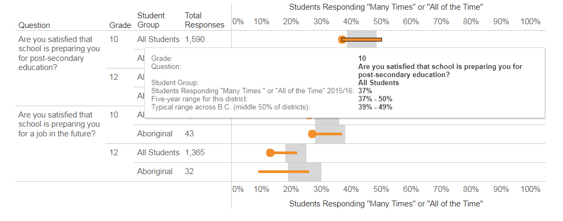

|  |  |
| --- | --- |
| **English** | **French** |
| Are you satisfied that school is preparing you for post-secondary education? |  |
| Are you satisfied that school is preparing you for a job in the future? |  |

11. Provincial Exams

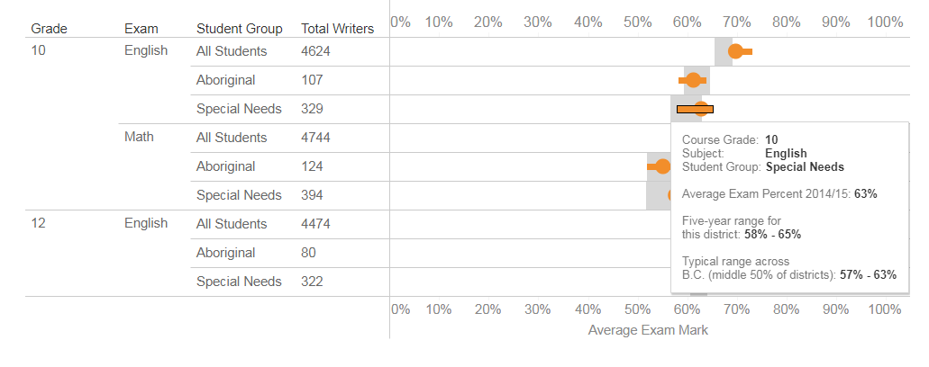

|  |  |
| --- | --- |
| **English** | **French** |
| Exam |  |
| Course Grade |  |
| Average Exam Mark |  |
| Subject |  |
| English |  |
| Math |  |

12. Transition to BC Post-Secondary

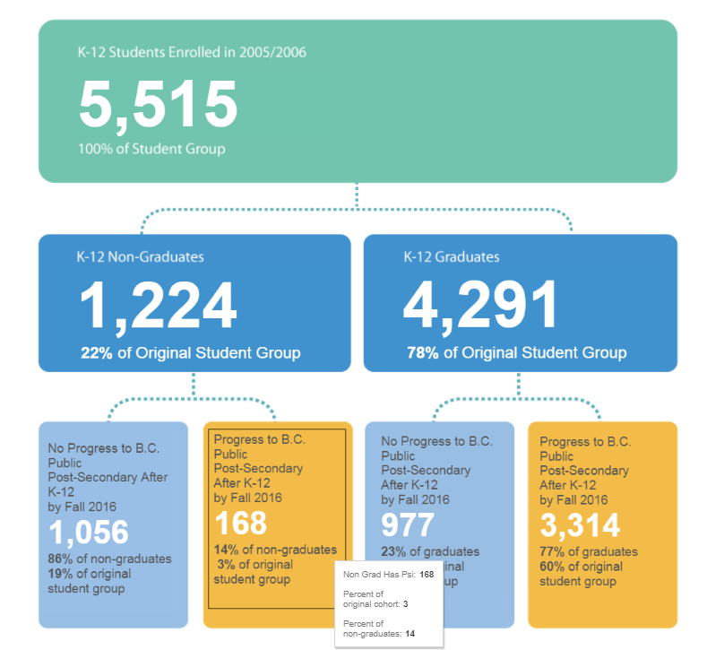

|  |  |
| --- | --- |
| **English** | **French** |
| K-12 Students Enrolled in 20015/2006 |  |
| 100% of Student Group |  |
| K-12 Non-Graduates |  |
| K-12 Graduates |  |
| ***X***% of Original Student Group |  |
| No Progress to B.C. Public Post-Secondary After K-12 by Fall 2016 |  |
| Progress to B.B. Public Post-Secondary After K-12 by Fall 2016 |  |
| ***X***% of non-graduates |  |
| ***X***% of graduates |  |
| Percent of original cohort: |  |
| Percent of Non-graduates: |  |